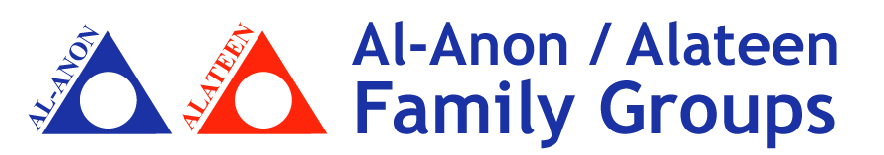

Dear doctor/ social worker/educator,
As a member of the worldwide fellowship of Al-anon and Alateen, I am contacting you about our local groups in Miami Dade County. These 12 Step groups support families affected by alcoholism. Most groups are meeting on Zoom, due to the coronavirus epidemic and are available in English and Spanish.
*Local website: Miami-Dade Al-Anon (Links to Zoom meetings)
*Phone service (members answer questions & concerns) 305-663-1432
*Al-anon World Service website for Zoom meetings everywhere: al-anon.org

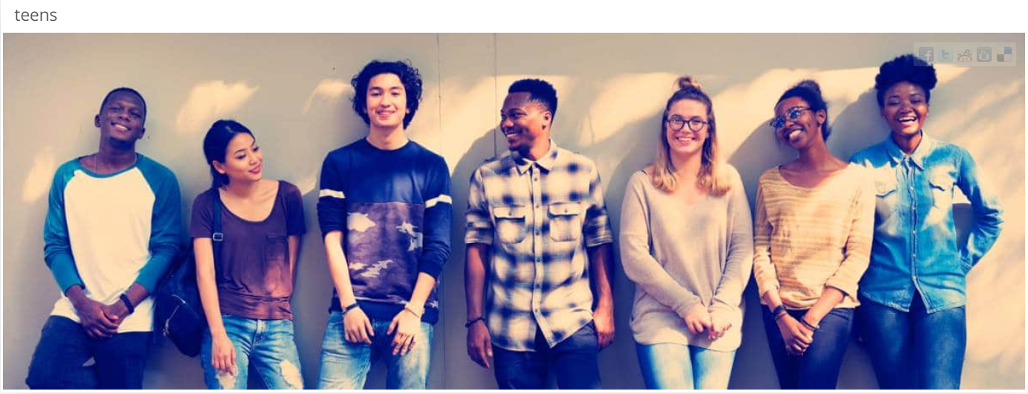
https://al-anon.org/resources-for-professionals/alateen-information/

More than ever, families need access to these services, especially kids. We look forward to resuming our meetings in person, as restrictions ease from the pandemic.
Help us to help and give support to our children. The moment is now.

Thank you.
Public Information and Cooperating with the Professional Community Committee  Al-anon Information Services in South Florida  Info@alanonsofla.org | SCAN ME

